How to Silent-install PADS Flow 9.3 and PADS updates/patches.

Create the “Session” install file for PADS 9.3

- Extract PADS9.3.zip – which can be downloaded from Mentor Graphics SupportNet – to a folder accessible on the network. This will be your source folder. For reference, I’ll call this \\server\folder\PADS9.3.
- Run the extracted PADS9.3_mib.exe file. This will immediately install (unpack) the MG Install program on your computer. Cancel out of the first window (Hardware Key/Licensing) when it appears to cancel the PADS installation.
- You’ll find a new entry in your Start Menu. Launch the Mentor Graphics Batch Tool.
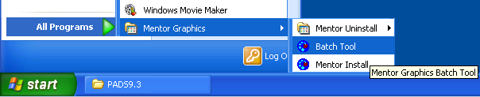
- Use the Wizard option your first time. The Advanced choice will not be available.
- Part 1: you’ll need to set the path for the repository. Generally, it’ll be something like \\server\folder\PADS9.3\PADS9.3_mib.exe. Click “Next” a few times.
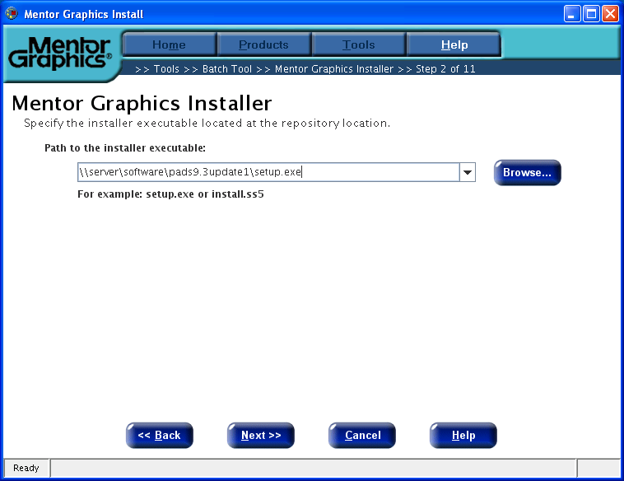
- Part 2: you’ll configure the client settings. This includes defining the target folder and selecting which products will be installed. Of note, be sure to read and agree to the license page so that the installer remains automated:
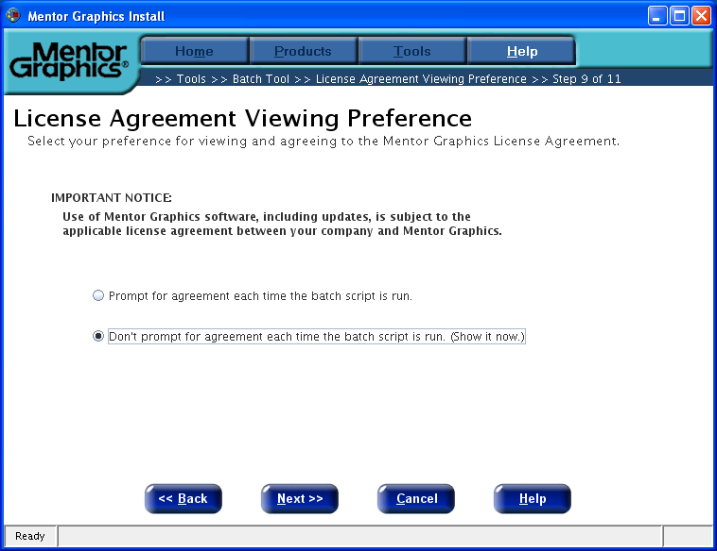
- Upon completion, a file called batchInstall.bat will be created in your PADS9.3 installation source folder. There are some changes you’ll need to make before this will work:
  - Modify the registry to add license server information with setup. Replace %LICPATH% with your license server, for example, “1717@license.server.com”. Mentor Graphics labels a place for you to add this:
    - REG ADD "HKLM\SYSTEM\CurrentControlSet\Control\Session Manager\Environment" /v MGLS_LICENSE_FILE /d 1717@license.server.com /F
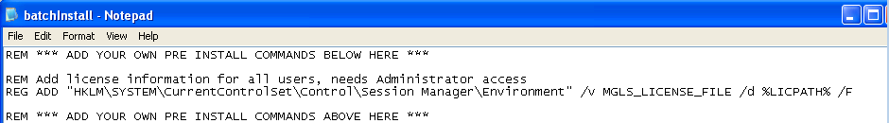
  - Optionally, you should create an install-log in a central location. Adding the command below will help you keep a record of who is installing PADS:
    - ECHO %USERNAME% (%DATE% %TIME%): %COMPUTERNAME%: Completed INSTALL of PADS 9.3.0 >> "\\server\logs\padsuser.log"

Create the “Session” install file for PADS 9.3 update 1

- Extract PADS9.3update1.zip to a folder that is accessible from the network.
- Run setup.exe in the newly created directory.
- Go to the Tools menu and start the Batch tool. Shortly, you’ll be prompted to start the Wizard:
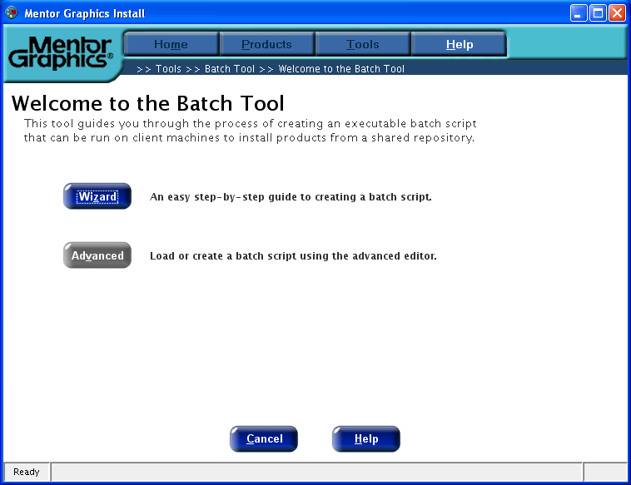
- In steps 2 through 6, specify the location of the source files on your file server.
- In steps 7-8, specify which applications you’ll need to patch. This should coincide with the applications you installed in the primary PADS setup.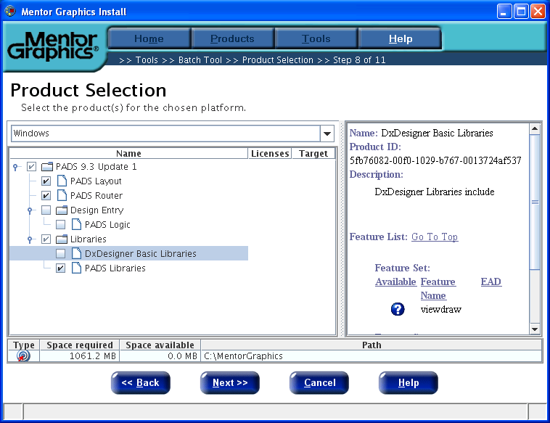
- Completing the Batch Install Wizard will generate a second batchInstall.bat file, this time in the PADS9.3update1 directory.

Create the final installation batch file

- Lastly, you’ll want to tie the installers together. This is a quick and easy step, but you should spend a moment to add some in-line documentation. The important lines to include are:
  - CALL \\server\folder\PADS9.3\batchInstall.BAT
  - CALL \\server\folder\PADS9.3update1\batchInstall.BAT
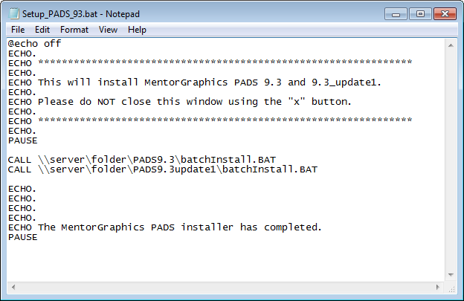
- Once you’re done with this, users will be able to install PADS quickly and easily!

